# CS 255 System Design Document Template

## UML Diagrams

### UML Use Case Diagram

### UML Activity Diagrams

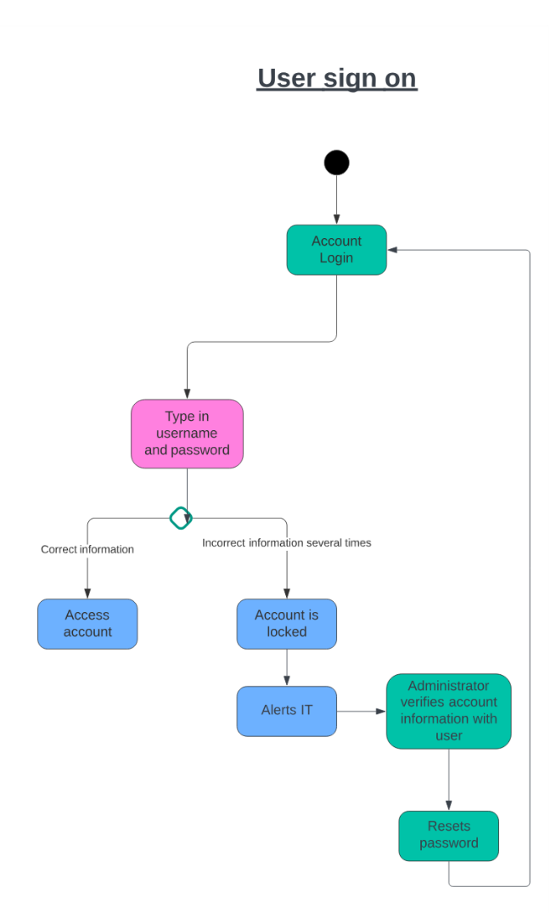

### UML Sequence Diagram

### UML Class Diagram

## Technical Requirements

1. Payment Validation: Validate incoming payments to ensure accuracy and security.
2. User Request Validation: Implement a mechanism to validate user requests for consistency and legitimacy.
3. User Permissions: Define and enforce user permissions to control access levels and actions within the system.
4. Package Disabling: Provide the ability to disable or deactivate packages as needed.
5. Login Requests: Manage and validate user login requests for secure access to the system.
6. Password Reset Requests: Implement a secure process for users to request and reset their passwords.